Website comments (May 22, 2023)

# General

* Adapt website for mobile screens – On-going
* Change address from OMM-Citra to OMM Bldg. - Done

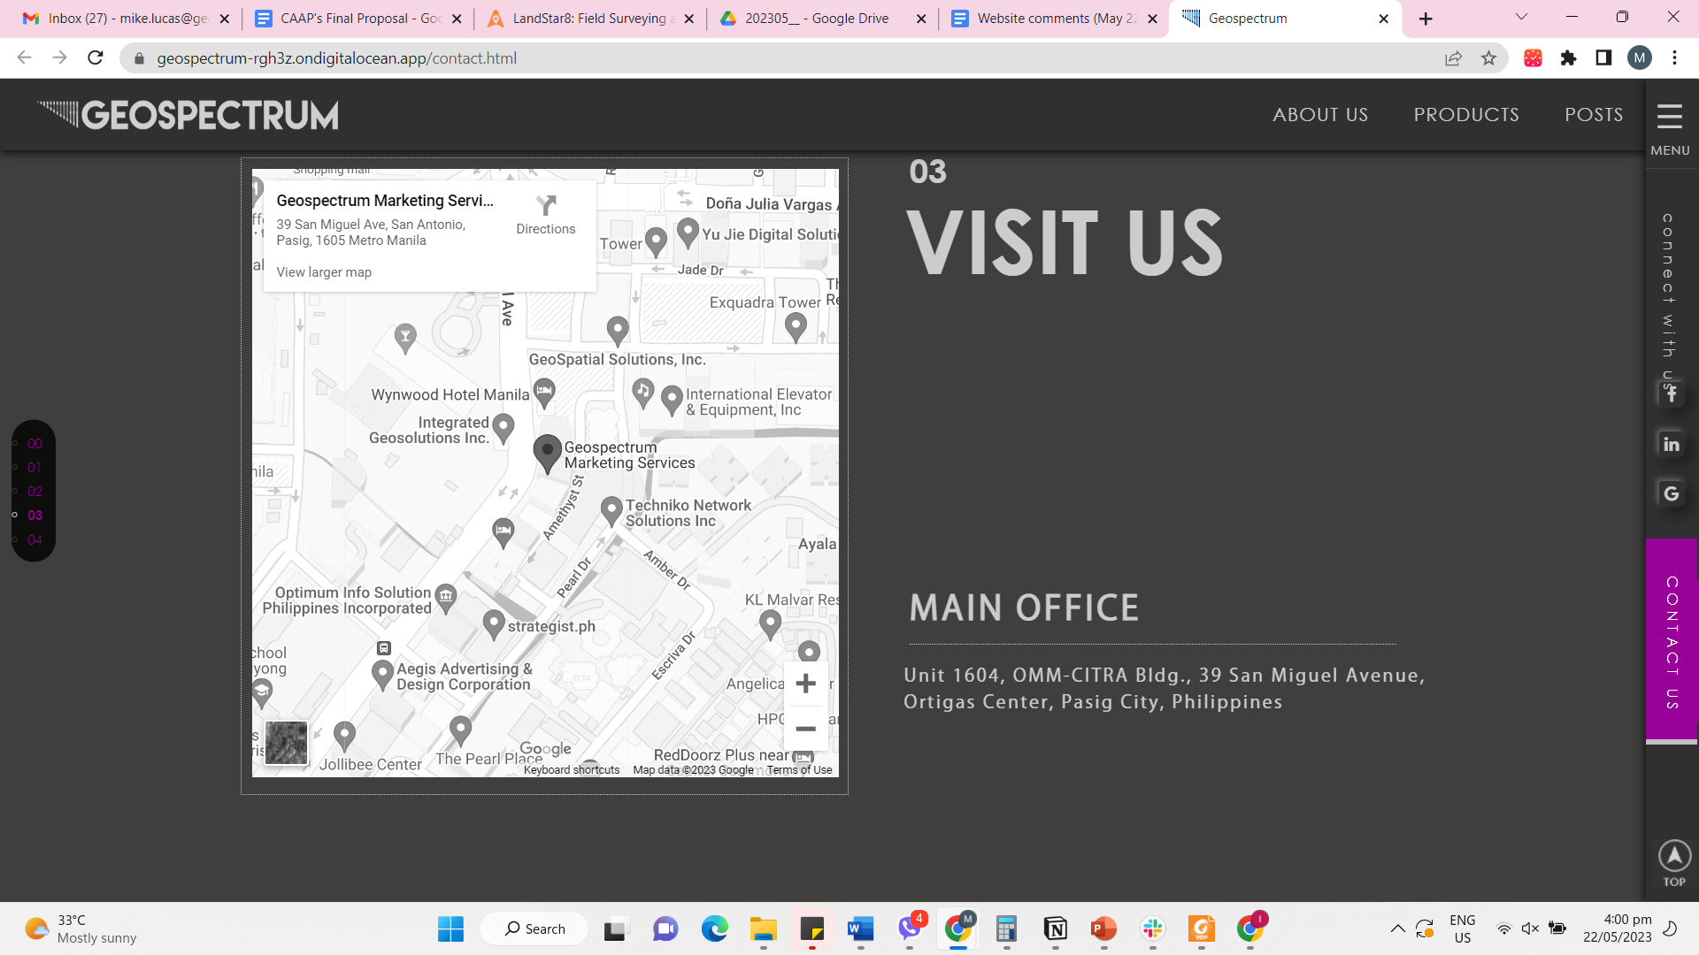

* Navigation adjustment, e.g., links lead users to correct section - Done
* Firefox menu does not display content unless mouse is scrolled unlike in Chromium-based browsers – Firefox has issues with CSS so the only way to solve this is to remove the reveal effects. Just a note that the Chrome browser market share is 68% compared to Firefox which is only 7% in 2021 (https://backlinko.com/browser-market-share). Without the reveal effect your website would feel very static. Are you going to sacrifice the 68% over the 7%?
* Menu section is inconsistent between pages (some pages have their menu unclickable or have unclickable button in it) - Done
* Navigation adjustment such that everything is concise, e.g., About Us contains Products and Services - Done

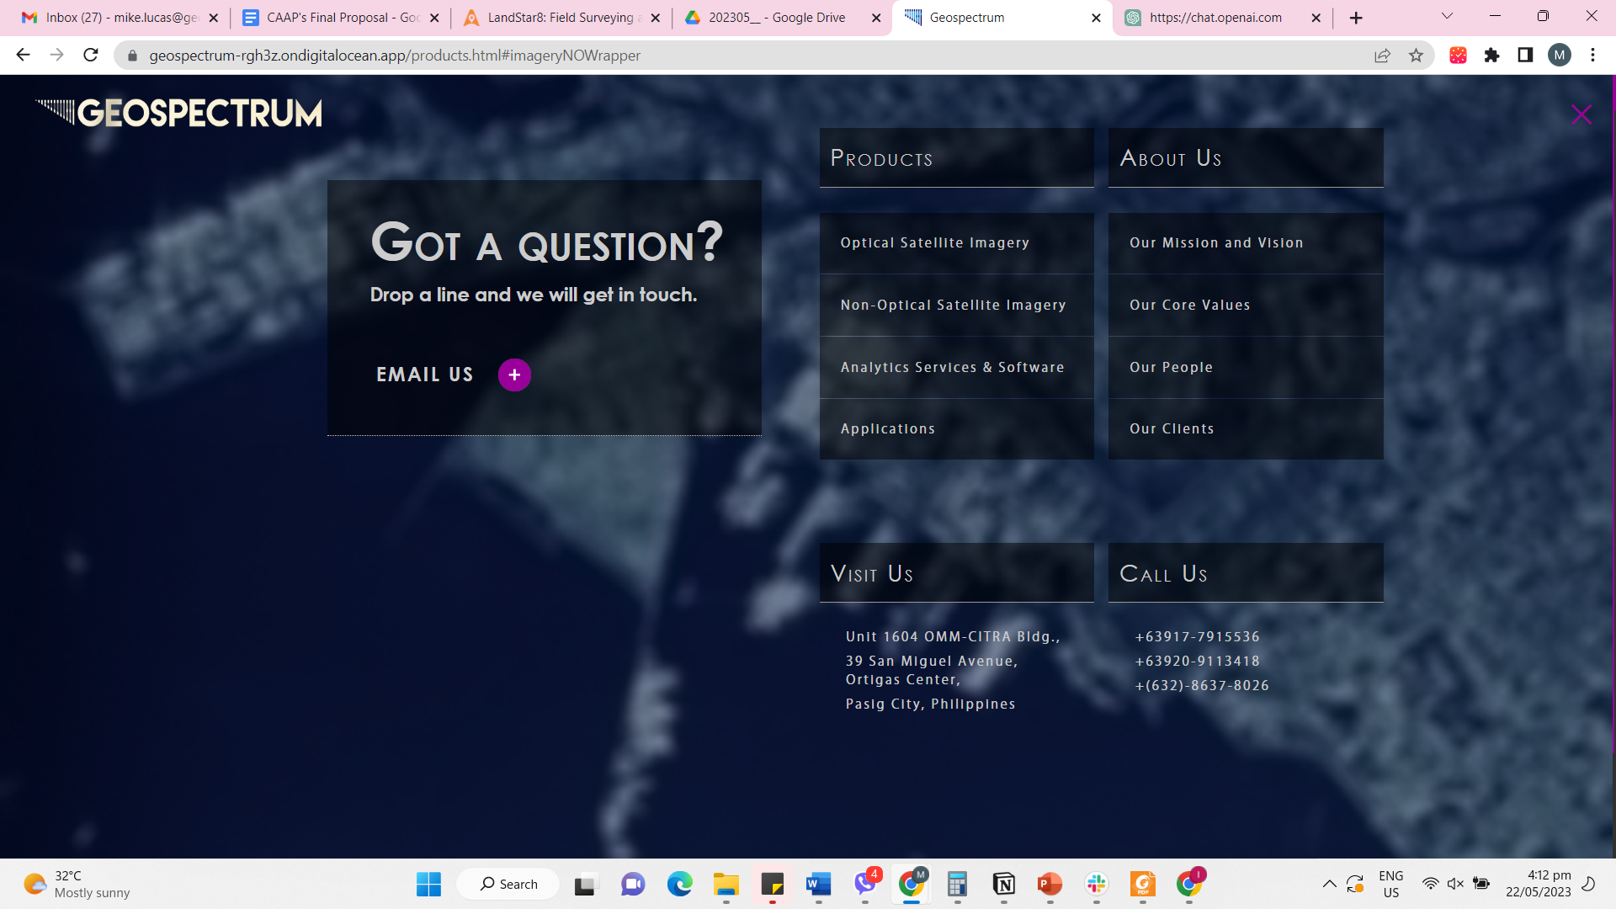

* The description should remain at the top and not be affected by the expanded action of the bullet points. - Done

# Landing screen

* Change image order of Taal images on landing screen (from before to after) - Done
* Adjust position of elements such that layout is static during resizing and zooming in and out – On-going
* Modify the photo visualization so that the word "Mount" is not visible unless it is selected or being pointed at by the cursor. - Done

# About us

* Change logo color from yellow to white - Done
* Allow space for new sections such as “Corporate Social Responsibility”, placeholder for a moment - Done
* Change ‘Join our Team’ to ‘Our Team’ - Done

# Products

* Change Geospectrum logo color from yellow to white - Done

# Posts

* Career Opportunities should focus on discipline and qualifications instead of positions available (Place holder for a while, will send once available) - Pending
* Remove Visit Us section - Done

# Contact us

* Change map color and map style such that map is vibrant and emphasizes location of office – Changed to default color theme (Google Map).
* Change Privacy Policy content to static (Policy Policy is removed once mouse is not hovered over privacy policy button) - Done
* Modify the input types of the text fields in the Contact Us form, specifically for the email address, contact number, subject, and adjust the spacing of the message section. - Done